Modules, Libraries, Framework – Exercises
Exercises and homework assignments for “Introduction to Programming with AI” course at SoftUni.

Unit Converter Library
Implement a unit converter library that converts metric, weight, and temperature units.
Use ES6 modules with "import / export" (not CommonJS).

Specific Unit Converters
- Metric converter: metric-converter.js
  - Convert between mm, cm, m, km, inch, foot, yard, mile
- Weight converter: weight-converter.js
  - Convert between mg, g, kg, t, lb, oz
- Temperature converter: temperature-converter.js
  - Convert between cel, fah, kel
Implement each converter as a JS module, with the following exported members:
- unitsSupported() string array of supported units (returns a copy)
- convertUnits(value, fromUnit, toUnit) converts the units, throws error if certain unit is not supported, default export

Hints
First, create a new project folder for your app, e.g. `unit-converter`, and open it in VS Code.
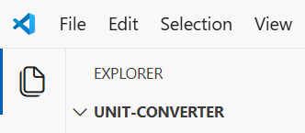
Implement the code yourself or with an AI prompt. This is how the code may look like:
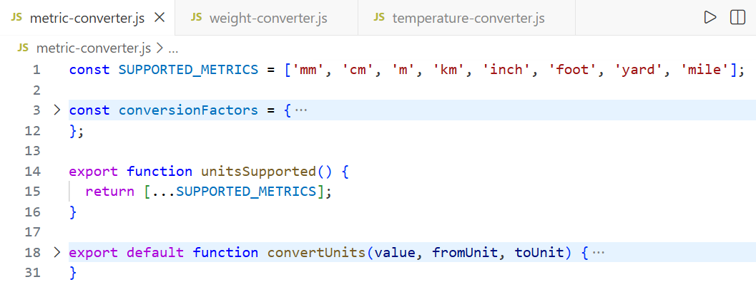

Unified Unit Converter
Implement unit-converter.js module, which combines all other converters, with the following exported members:
- unitsSupported() string array of supported units, combined (returns a copy)
- convertUnits(value, fromUnit, toUnit) converts the units, throws error if certain unit is not supported, default export

Console Unit Converter
Create a console-based unit converter app, which imports the unit converter library, prints all supported units, then converts a few pairs of units and prints the result on the console.

Hints
Once the library modules are defined, just import them and implement the conversion logic. This is a sample implementation:
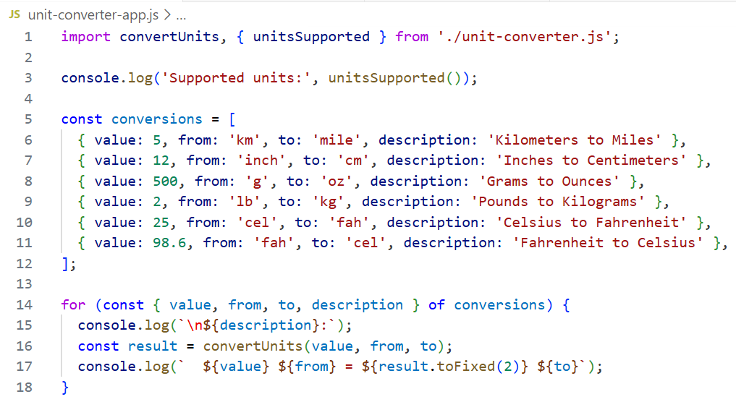

HTML Unit Converter
Create a simple HTML + CSS + JS unit converter app, which imports the unit converter library and converts units.
- Create 3 separate tabs on the left side:
  - Metric Converter, Weight Converter, Temperature Converter
- Display the converters UI on the right side
- Import the unit converter library for the conversion logic

Hints
Implement the HTML converter with a simple GitHub Copilot prompt:
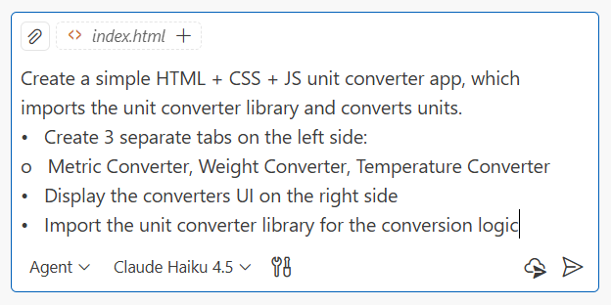
Open the HTML file generated from the AI dev agent to test how it works. It will not work and this is expected! Press [F12] to see the errors on the Web browser console:
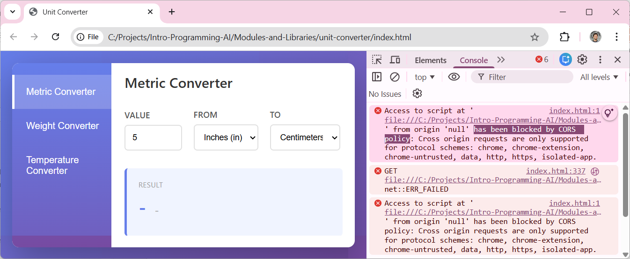

The CORS Problem
What happens? Why does your app fail to load JavaScript libraries for unit conversion? Look at the code:
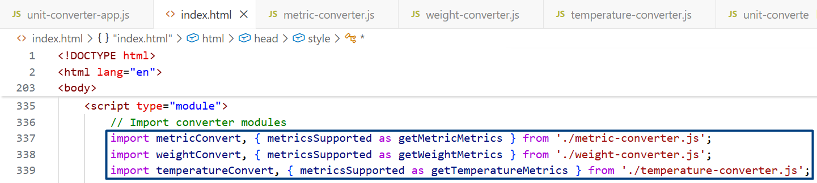
Modern Web browsers support module importing. A JS script inside an HTML file can load other scripts, using the "import" statement. The problem comes from security restrictions (Cross-Origin Resource Sharing policy – CORS). By design, in Web browsers an HTML page loaded from a local file is not allowed to access other files on your computer. You can ask your browser to generate AI explanation for this problem in the Browser Dev Tools Console:
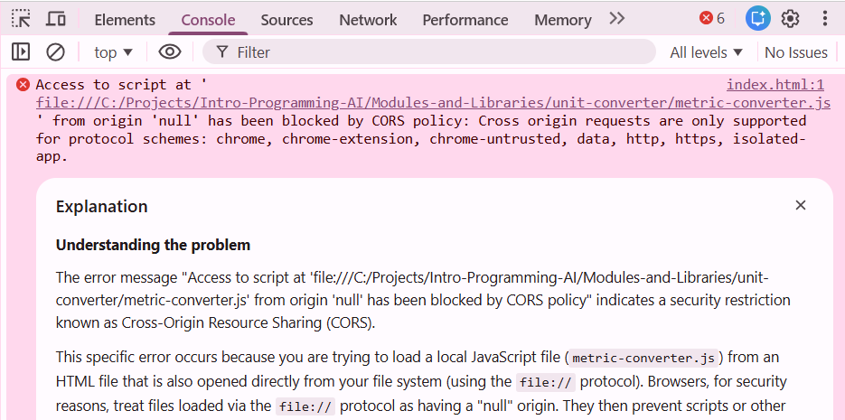

Running the App in a Web Server
To fix this problem, run your app on a Web server. Just run this command in your app root folder:
npx http-server
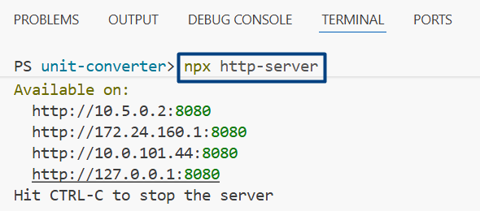
This command runs a local Web server and serves the current folder. You can open your HTML app through the default Web address:
http://127.0.0.1:8080
This is an example of how your app may look like, when it is loaded from a local Web server:
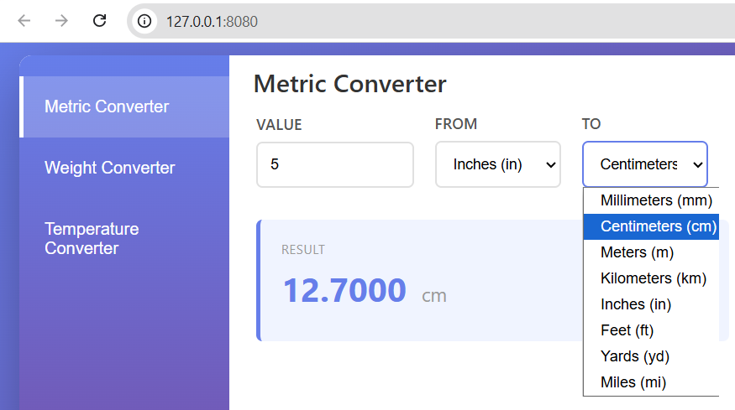

Blocking Code
In this exercise we will demonstrate the concept of "blocking code" in computer science.

Blocking Code in the Console
Run this sample code in VS Code:
function blockingFindSum(limit) {
let sum = 0, result = "0";
for (let i = 1; i <= limit; i++) {
if (i % 1_000_000 === 0) {
console.log(`Calculating [${Math.round((i/limit)*100)}%]`);
}
sum += i;
result += " + " + i;
}
return result + " = " + sum;
}

console.log("Start...");
const result = blockingFindSum(30_000_000);
console.log("Done.", result.length);
The result will be like this:
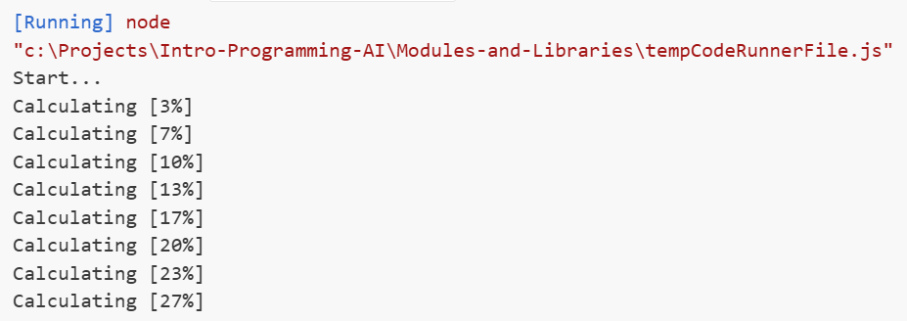
The speed of increasing the percentages depends on your computer speed. Powerful high-end laptops will run this code faster than old laptops. You can change the number of loop cycles to adjust it for your hardware.

HTML Page with Blocking Code
To illustrate the effect of blocking code in the Web browser, create a simple HTML page to run the function blockingFindSum(30_000_000) on a button click. This is an example of how the HTML page may look like:
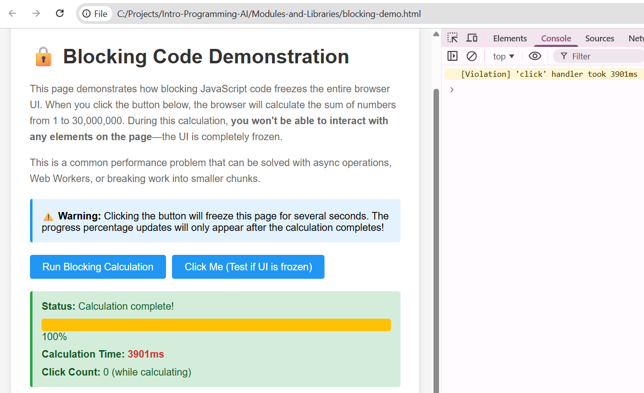
Not that the browser UI will be frozen for the period of the blocking calculation. On the Dev Tools console you will see a warning message that tells you "Hey, your button click event handler runs too long make it faster or tun a asynchronous background task".

HTML Page with a Non-Blocking Code
Ask the AI dev agent to run the heavy calculation as non-blocking code.
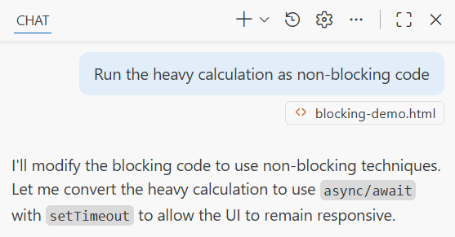

List GitHub Repos
GitHub has a public API, which can list users, repositories, commits, pull requests and many more. This is a sample URL from the GitHub API, which lists all repositories for given user `nakov`:
https://api.github.com/users/nakov/repos
When you open this URL with a Web browser, you will see the JSON result, returned from GitHub API:
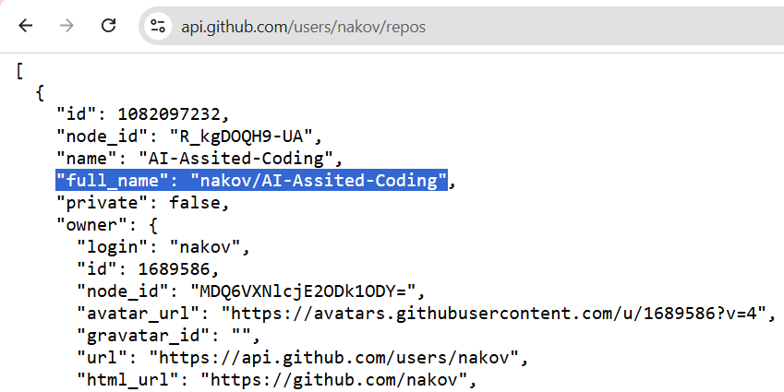

List Repos – Console App
Write a simple async function to list all GitHub repositories for given username. Return the JSON array, returned from the GitHub API.
async function listGitHubRepos(username) --> object[]

let repos = await listGitHubRepos('nakov');
for (let repo of repos)
console.log(repo.full_name);
This is a sample result from the above code:
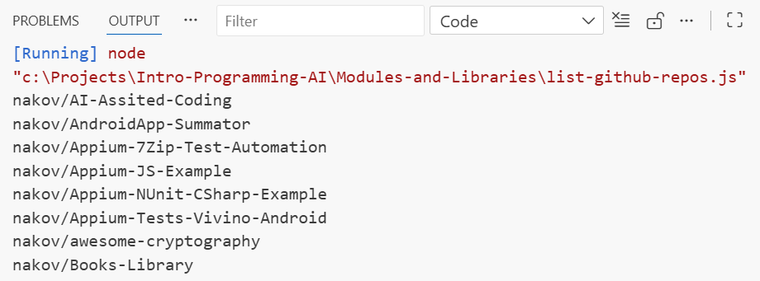

List Repos – HTML App
Using the existing code, implement a HTML + JS app to enter a username and list all GitHub repos for this username. Implement pagination to ensure all repos are listed, not just the first page. This is a sample result:
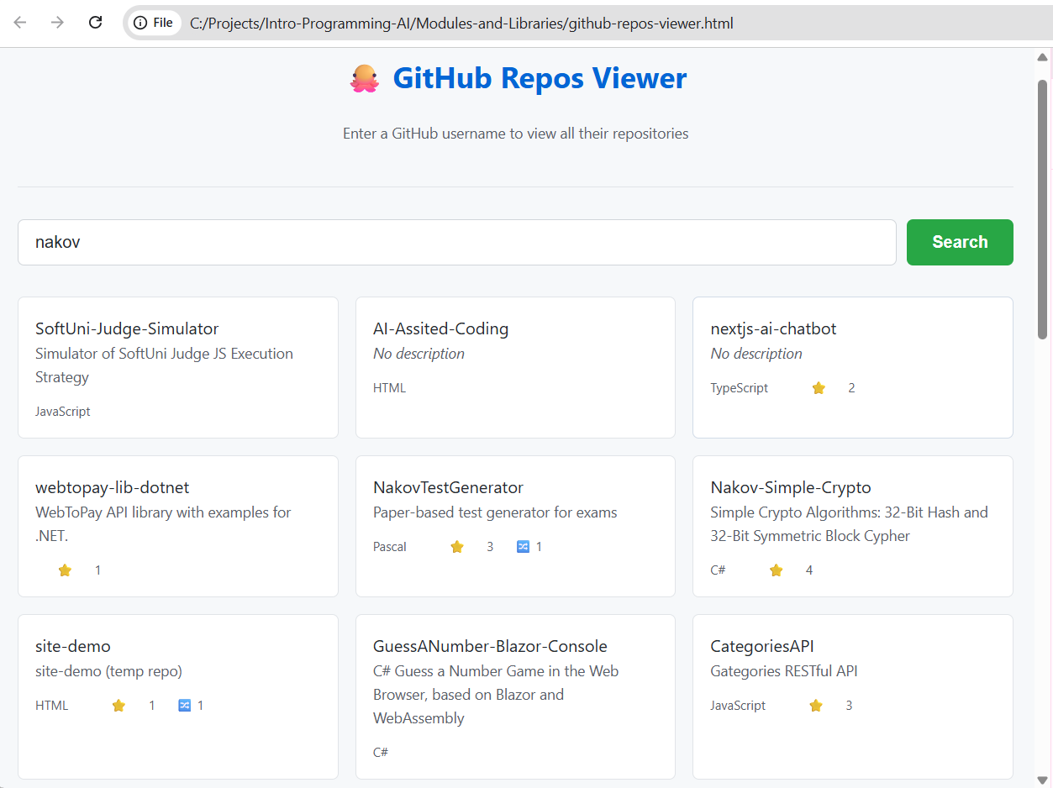

Invoices App Mono Repo
In JavaScript, a monorepo is a single app folder that contains the source code for multiple packages, apps, or libraries. Large JS projects typically use monorepo to organize app components as workspaces.
We are going to build a JS project "Invoices-App", consisting of several sub-components:
- invoice-repo – a library, which will hold invoice data types and logic to manage invoices
- invoice-console-app – a simple console app, which will demonstrate how to create / edit invoices
- invoice-web-app – a Web app, which will manage invoices
Create an monorepo structure to hold the above-mentioned components.
- Use a flat structure for sub-components.
- Keep sub-projects empty. We shall implement them later.

Hints
Run an AI prompt to build the app structure as monorepo with workspaces:
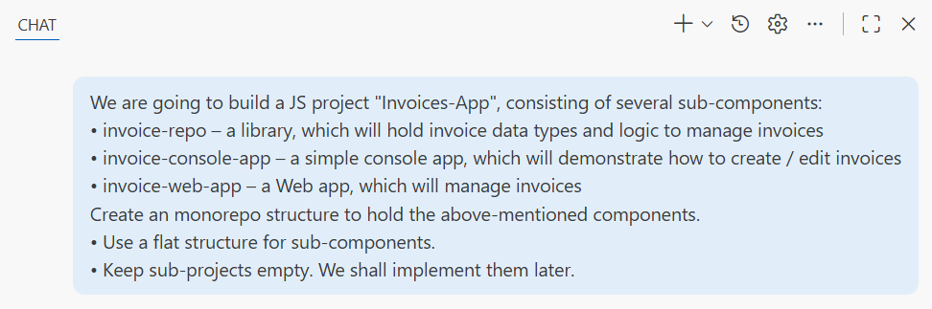
This is an example of how your project may look like, when the app structure is successfully created:
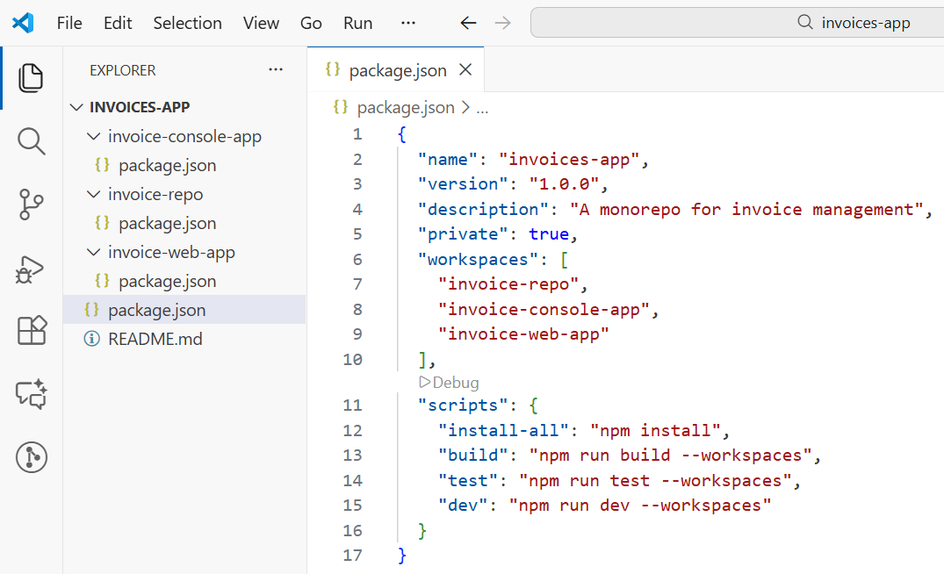

Invoice Repo
Use the already defined app structure. Work in the "invoice-repo" folder.
Define a TypeScript package `invoice-repo`, designed to hold and process invoices.
- Define package.json project manifest file
Initially, define the following data types:
- IssuerCompany – name, id, tax id, address, manager, IBAN (all properties are mandatory)
- RecipientCompany – name, id, tax id, address, manager (only name is mandatory)
- RecipientIndividual – name, national ID number (optional)
- Recipient – either a company or an individual
- ProductUnit – pcs | kg | liters | meters
- InvoiceItem – product, quantity, unit, price, VAT rate, value (without VAT)
- Invoice – id, date, issuer, recipient, list of items, subtotal amount, VAT amount, total amount
Implement a class InvoiceRepo, which holds:
- Settings: default VAT rate, invoice issuer (these settings are shared for all invoices)
- Recipients: holds a list of recipients, implements find by ID, find by name, add, delete
- Invoices: holds a list of invoices, implements find by ID, add, delete
Implement a function to return sample data (5-10 invoices for testing purposes):
- generateSampleData() InvoiceRepo
- The default VAT is 20%
- Company tax id numbers are generated as [country code] + company id, e.g. 200776618 BG200776618
Split the package into 3 modules:
- invoice-types.js – export all types
- invoice-repo.js – export as default InvoiceRepo
- invoice-repo-sample-data.js – export as default generateSampleData()
Generate documentation for your package: README.md.

Hints
Use AI prompts to generate the invoice repo. This is an example of the code generated:
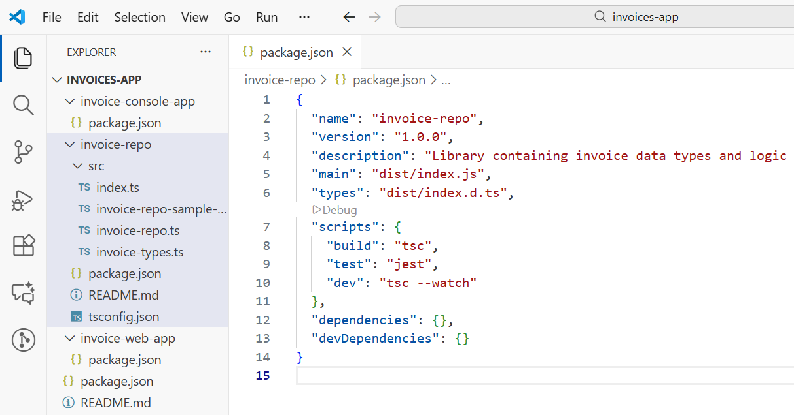

Invoices – Console Client App
Use the already defined app structure. Work in the "invoice-console-app" folder.
- Run `npm install` in your root project folder to link your project packages.
- Build the project `invoice-repo` so that its code becomes available for importing from the other apps.
Create a simple console-based app to demonstrate how the invoice repo works. Start from the sample data, add an invoice, find an invoice, edit an invoice, delete an invoice.

Hints
First, run `npm install` in your root project folder:
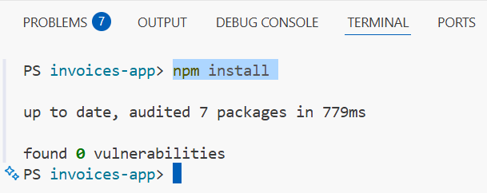
This command link project sub-packages in the folder `node_modules`:
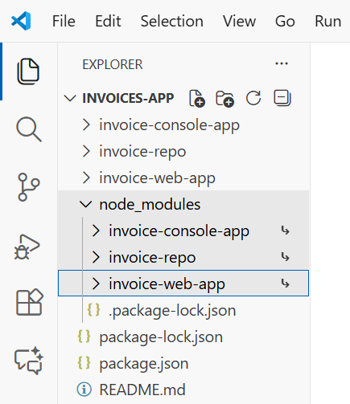
Next, run `npm run build` in your ` invoice-repo` project folder:
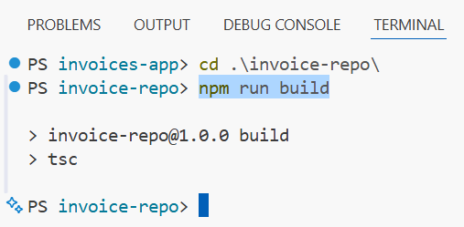
Now, in the ` invoice-console-app` you can import members from invoice repo like this:
import { InvoiceRepo, generateSampleData, Invoice, RecipientIndividual }
from "invoice-repo";
Now you can play with the sample invoices, returned from generateSampleData(). Example:
import { InvoiceRepo, generateSampleData, Invoice, RecipientCompany }
from "invoice-repo";

const repo = generateSampleData();
console.log(repo.getAllInvoices());
Now you can run your app like this:
cd invoice-console-app
npm run build
npm start
This is a sample output at the end, when we run the console client app.
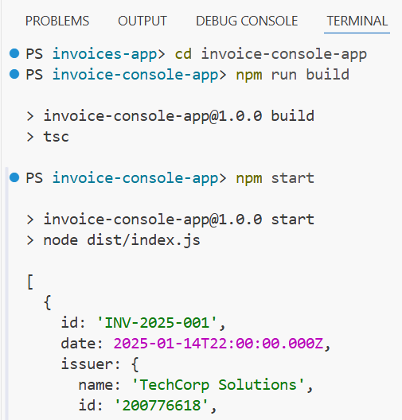

Invoice Repo Tests
Now, implement automated tests for the `invoice-repo` package. Use Jest framework.

Hints
Run an AI prompt in Agent mode.
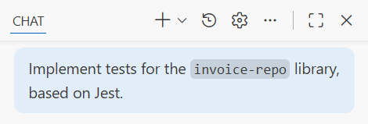
This is a sample of the final output from the test runner.
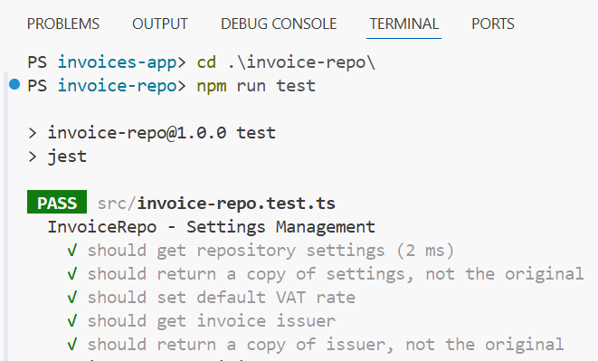

Invoice Editor App
We want to build a front-end app (Vite + HTML + TypeScript) to view / edit / generate invoices.
Implement the app step by step, don't hurry to write code now!

Create Vite App
Use the already defined app structure from the JS project "Invoices-App".
Create an empty Vite + TypeScript app (without a framework) in the "invoice-web-app" folder.
This is an example of how your Vite app may look like in VS Code:
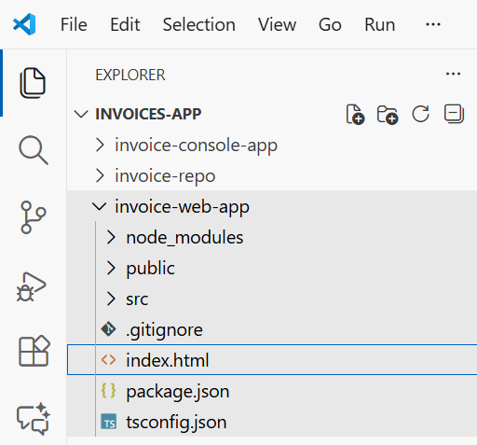

Implement Layout, Pages and Routing
Implement a simple layout, routing and page navigation system to split the app UI into pages.
- Keep the implementation simple and straightforward.
- Install Navigo – a simple page navigation library.
- Implement app layout: header + page content + footer.
  - In the header place a menu navigation: Home | Invoices | Clients | Config
  - In the footer print a standard copyright message.
- Implement empty app pages with routes:
  - / – app home will hold links to invoices page, clients and config page
  - /invoices – will hold a table of invoices
  - /invoices/:id/view – will hold an invoice viewer
  - /invoices/:id/edit – will hold an invoice editor
  - /invoices/:id/pdf – will render an invoice as PDF
  - /clients – will hold a table of clients (individuals and companies)
  - /clients/:id/view – will hold a client viewer
  - /clients/:id/edit – will hold a client editor
  - /config – will hold and editor for app config and issuer company data
- Keep the pages empty: just show a title
- Keep each page in a separate file.
- Use full-width, responsive layout for the app and pages.
This is a sample layout with pages and navigation:
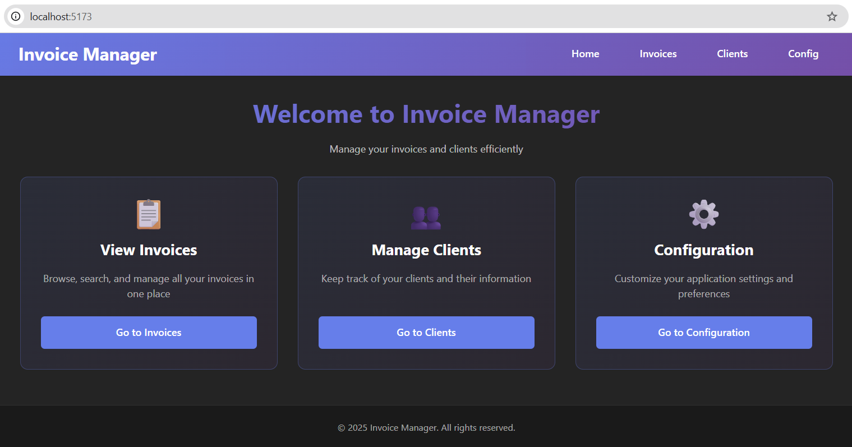

Global Data Repo
Define a global data repo for the Web app, holding the app data. Use the code already implemented in the `invoice-repo`. This data repo will be shared between all app pages. At app startup, populate the repo with sample data.

View All Invoices
Implement the "View All Invoices" page.
- List all invoices as a table.
- For each table row add [View], [Edit], [Delete] buttons.
- Buttons should redirect the other pages (will be implemented later).
This is an example of the "View All Invoices" page implementation:
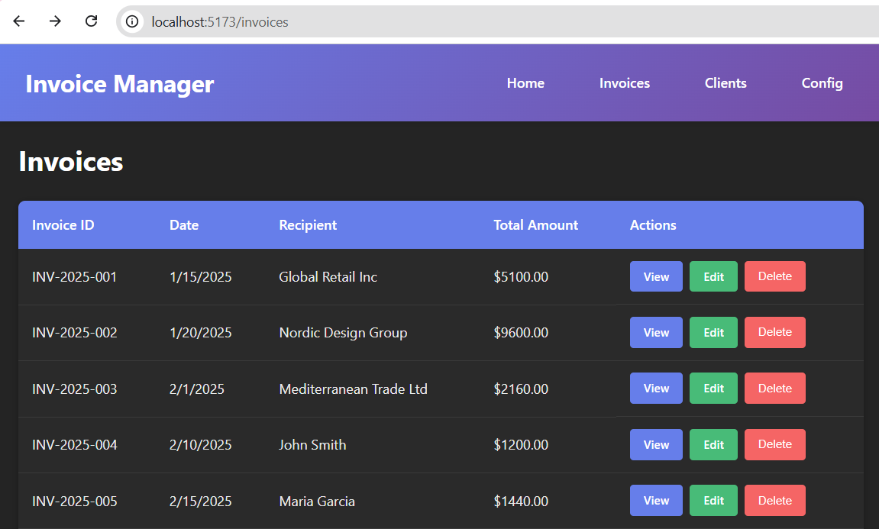

View Invoice
Implement the "View Invoice" page.
- Display invoice details, well formatted.
This is an example of how the page may look like:
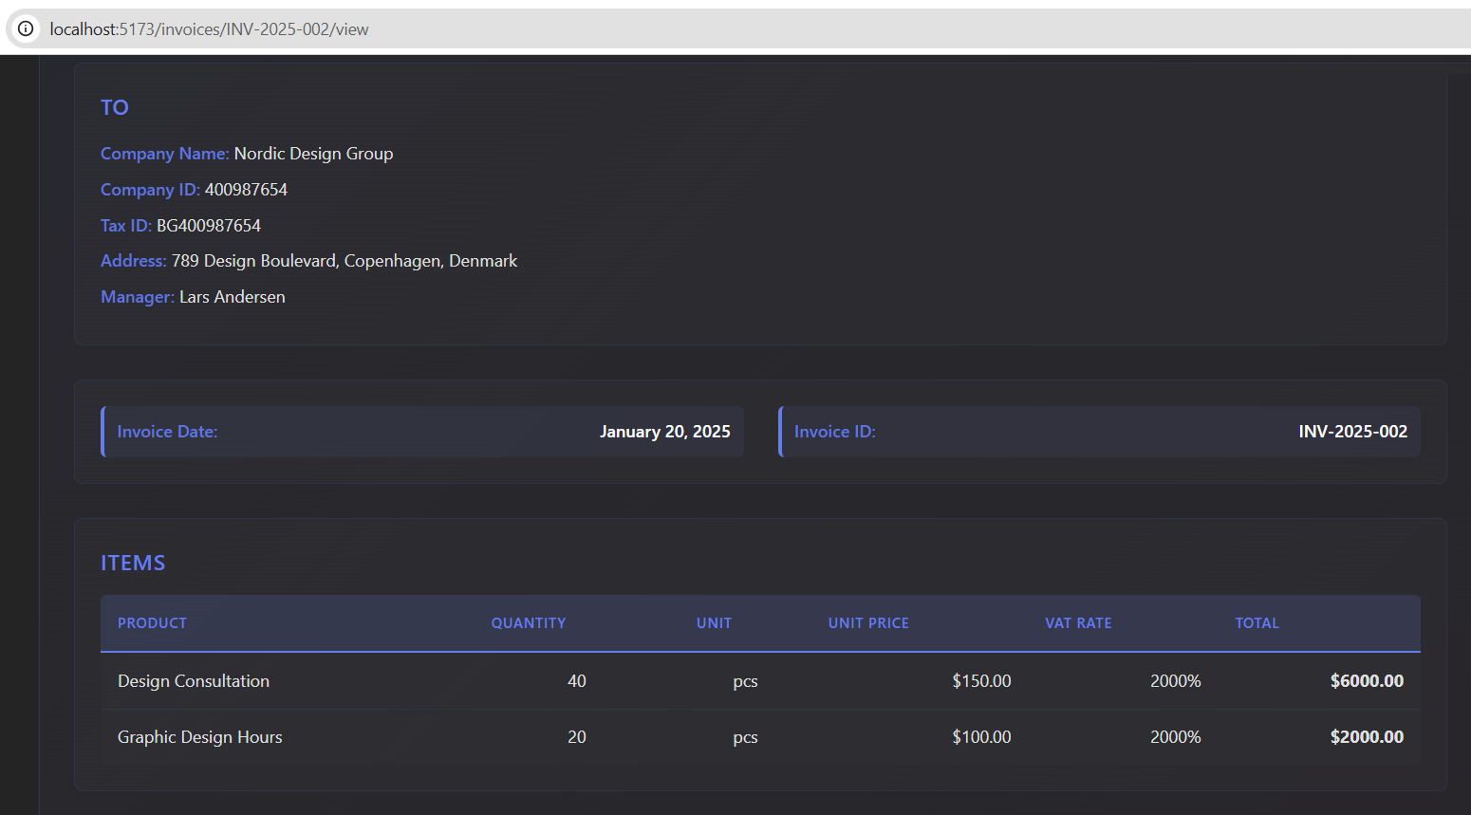

View All Clients
Implement the "View All Clients" page.
- List all clients as a table.
- For each table row add [View], [Edit], [Delete] buttons.
- Buttons should redirect the other pages (will be implemented later).

View Client
Implement the "View Client" page: display client details, well formatted.

View / Edit Config
Implement the "View / Edit Config" page.
- Display config details: issuer company data + VAT default rate.
- Implement "Edit" button to modify the config data.

Add / Edit / Delete Clients
Implement the client editor: add / edit / delete invoice recipients (called shortly "clients").
- Implement the "Edit Client" page – display a form to edit client data.
  - Change the form fields when switching between an individual or a company.
- Implement the "Add Client" page – display a form to add a client.
- Implement "Delete Client" with a modal popup confirmation.
Note: this functionality is more complicated. You may need to run an AI prompt to implement it through a more-capable LLM model in GitHub Copilot, not with the fast alternatives.

Add / Edit / Delete Invoices
Implement the invoice editor: add / edit / delete invoices.
- Implement the "Edit Invoice" page – display a form to edit invoice data.
  - Implement a nested invoice items editor: add / edit / remove invoice items.
- Implement the "Add Invoice" page – display a form to add an invoice.
- Implement "Delete Invoice" with a modal popup confirmation.
Note: this functionality is even more complicated than the previous. You may need to run an AI prompt to implement it through the smartest available LLM model in GitHub Copilot!

View Invoice as PDF
Implement the "Invoice PDF" page.
- Install some popular PDF generation JS library.
- Implement invoice PDF renderer: take invoice data and generate a well formatted PDF document, holding the invoice details.
- Embed the PDF document inside the "Invoice PDF" page.
- Implement "Download PDF" in the "Invoice PDF" page.

